MSIS 638

Jia Liang Ma

Case 3.2aii

1. The data for the coffee manufacturing company example discussed in Case 3.2.a1 is repeated below.

|  |  |  |  |  |
| --- | --- | --- | --- | --- |
|  | Acidity (0-9) | Bitterness (0-9) | Aroma (0-9) | Cost ($/lb.) |
| Type 1 | 4 | 8 | 6 | 0.95 |
| Type 2 | 6.5 | 6 | 9 | 1.25 |
| Type 3 | 8 | 4 | 7 | 1.15 |
| Range | $$Acidity≥5.5$$ | $$Bitterness≤7$$ | $$7≤Aroma≤8$$ |  |

Below is the LP formulation for this problem including the additional restriction by the supplier and regulatory agencies.

$\min{0.95x_{1}+1.25x_{2}+1.15x_{3}}$ (Cost)

$4x_{1}+6.5x_{2}+8x_{3}≥5.5$ (Acidity)

$8x_{1}+6x_{2}+4x_{3}≤7$ (Bitterness)

$6x_{1}+9x_{2}+7x_{3}≥7$ (Aroma - min)

$6x_{1}+9x_{2}+7x_{3}≤8$ (Aroma - max)

$x_{1}+x_{2}+x_{3}=1$ (Sum equals 1 lb)

$x_{1}≥2x_{2}$ (Type 1 at least twice Type 2)

$x_{3}≤0.3\left(x_{1}+x_{2}+x_{3}\right)$ (Type 3 at most 30%)

$x_{1}≤x_{2}+x_{3}$ (Type 1 no more than other types combined)

$x_{1},x_{2},x_{3}≥0$ (Non-negativity)

1. Set up this LP problem in Excel and use Solver to solve it. *Remember to generate the Answer and Sensitivity reports.* Also remember to submit the solution Excel file. Hint: A decision variable in the right-hand side of a constraint can be represented by referring to the corresponding yellow cell.
2. What is the optimal cost for 1 lb. of the blend?

Ans: 1.08

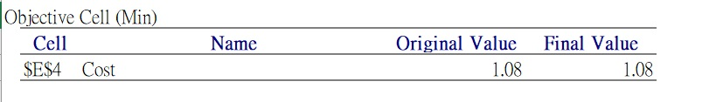

1. What are the optimal values of the decision variables?

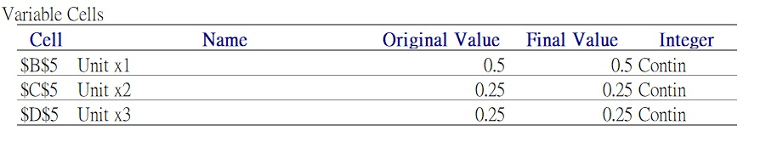

Type 1: 0.5

Type 2: 0.25

Type 3: 0.25

1. Which constraints are binding?

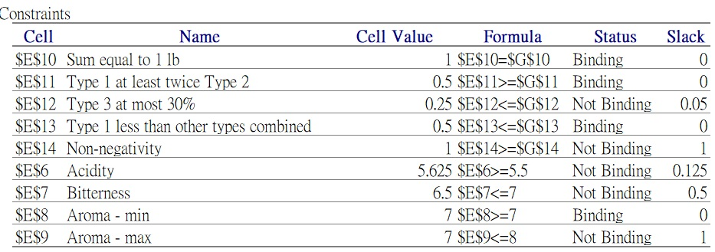

The constraints are binding:

Type 1 at least twice as Type 2

Type 1 less than other type combined

Aroma - min

Sum equal to 1 lb.

1. Remove the *non-binding* constraints from Solver and rerun Solver to find the optimal solution. Did the optimal solution change after removing the non-binding constraints? What conclusion you get?

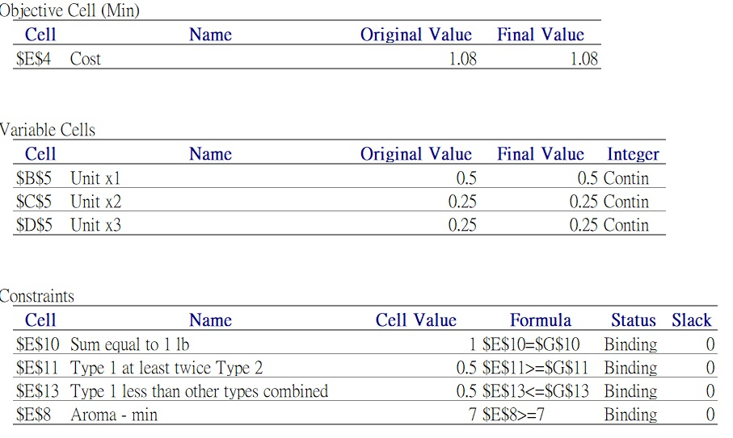

After removing the constraints, we observe that there is no difference between the former and later. To sum up, the non-binding constraints do not show any influence on the LP problem.